Manual Lathe Extension

An integration of Old with New

|  |  |
| --- | --- |
| Kedar More*1  *Roll no.-201536,*  1Department of Mechanical  *Fr. Conceicao Rodrigues College of Engineering, Mumbai University*  *Sector-9A, Vashi, Navi Mumbai, India*  1kedarmore5050@gmail.com | Vaibhavi Patil*2  *Roll no.-301537*  2 Department of Electronics and Telecommunication  *Fr. Conceicao Rodrigues College of Engineering, Mumbai University*  *Sector-9A, Vashi, Navi Mumbai, India*  2vaibhaviapatil1997@gmail.com |

***Abstract—* This abstract discusses an enhancement in conventional lathe machine. Now-a-days amongst many products which are manufactured using modern technology which is a communion of computer software, hardware and firmware, the lathe machine plays a vital role in this manufacturing sector. Hence, researchers are trying out new enhancements in the conventional lathe machine. The latest amongst these developments is the use of the Computer Numeric Control for automation of the manual lathe machines, which are termed as Computer Numeric Control lathe machines. Although, these lathe machines provide desired accuracy and efficiency but they require a huge capital. Also, due to modernized industrialization, replacing the manual lathe machines with more efficient Computer Numeric Control lathe machines cannot be affordable to all the small scale and medium industries. In this dilemma, the designing of an extension for manual lathe can enhance its existing properties. This extension will have almost all the characteristics of a Computer Numeric Control machine. Hence, this project is an attempt to equip the conventional lathe machine with a controlling device i.e. a microcontroller to control the motor movement.**

**Keywords—** ***CNC, Lathe.***

# INTRODUCTION

Lathe is a [tool](https://en.wikipedia.org/wiki/Tool) that rotates the workpiece about an [axis of rotation](https://en.wikipedia.org/wiki/Axis_of_rotation) to perform various operations such as [cutting](https://en.wikipedia.org/wiki/Cutting), [sanding](https://en.wikipedia.org/wiki/Sanding), [knurling](https://en.wikipedia.org/wiki/Knurling), [drilling](https://en.wikipedia.org/wiki/Drilling), [deformation](https://en.wikipedia.org/wiki/Deformation_(engineering)), [facing](https://en.wikipedia.org/wiki/Facing_(machining)), turning with tools that are used to perform these operations on the workpiece to create an object with [symmetry](https://en.wikipedia.org/wiki/Rotational_symmetry) about that axis. An operator has to rotate the two wheels in order to change the position of the tool and move it to the desired

location. The wheels have some graduation marks which indicate the distance of the traveled path according to its revolution.

In early 1960s, CNC lathes where introduced as improved productivity and precision type lathe machines with computer numeric control(CNC). Now, the latest machinery of CNC milling machines and lathes employ microprocessors in order to read the user created G and M codes. The calculations for generating a pre-defined path for the tool are done based on these codes.

So, this shows that the CNC lathe machines have various benefits over manual lathe machines including the improved efficiency, accuracy, reliability and also reduced human labor. Hence, the conventional fully human operated lathe machines are completely discarded in the advent of installation of “CNC” lathe machines to design more finished products. But this involves large capital investment.

So, our aim is to design an extension for our conventional lathe machines whose functionality will be the same as that of CNC. This part will be similar to the cross slide or dead end, which can be removed. Thus, without hindering the normal manual lathe this extension can be used as a CNC. When we want our manual lathe back just detach it. User need to fill the system until full tank and not allowed to choose how much they wish to fill base on different condition.

# LITERATURE REVIEW

*A. History of Lathe*

Lathe is a very ancient tool and its first use dates back to 1300 BC in Egypt. Ancient Romans came to know about this machine and they further developed this machine. During the medieval period, the use of this machine had spread to most parts of Europe and it was during the Industrial revolution when this machine gained popularity with its use in all the industries. After the development of electronics, automated lathes have been developed.

1. *Evolution of Lathe*

The first lathe was a simple lathe which was is now referred to as two-person lathe. One person would turn the wood work piece using rope and the other person would shape the work piece using a sharp tool. This design was improved by Ancient Romans who added a turning bow which eased the wood work. Later a pedal (as in manual sewing machines) was used for rotating the work piece. This type of lathe is called “spring pole” lathe which was used till the early decades of the 20th century. In 1772, a horse-powered boring machine was installed which was used for making canons. After 1950, many new designs were made which improved the precision of work.

Lathes are classified depending upon their application and functionality as

1. Light duty lathe – These machines find their application in automobile, electronic, electrical industries and are manufactured from quality tested raw materials.
2. Medium duty lathe – These machines are powerful than the light duty lathes and can work on bigger work pieces and have more strength than the light duty lathes. [Click Here](http://www.yashmachine.com/wm-series-medium-duty-lathe/) to get more information on medium duty lathe machine.
3. Heavy duty late – These machines are manufactured from highest grades of materials like iron and steel. They are designed for high precision heavy duty operations.
4. All geared lathe – In all geared lathe, all the rotating components of the machine are driven by the same source at different speeds by using gears to perform various operations.
5. Imported lathe – Imported lathes are high quality lathes used for high precision operations.

Depending upon the modes of operation, the lathes can be classified as

1. **Manual lathe** – In these lathes, the tool handling is done manually and so the precision of work also depends upon the skill of the person handling the machine.
2. **CNC Lathe** – CNC lathes are completely automated lathes. We just have to feed the instructions into the computer and the lathe will perform the operations according to the data fed to the computer.

# III.SYSTEM OVERVIEW

Stepper Motor 1

Controller

(Arduino Mega)

Application

Stepper Motor 2

Fig3.1 Block diagram

# IV.WORKING

The Working can be divided into three sections:

1. *Android application:*

An android application is provided to the workers. They have to draw the side view of the required part in that application and Press “SEND”.

B. *Communication via Bluetooth.*

The communication between the Arduino and User application is provided via Bluetooth. When the User clicks on “SEND” button, appropriate dimensions of the diameters at specific interval of length are send as an array.

C*. Shaping Action.*

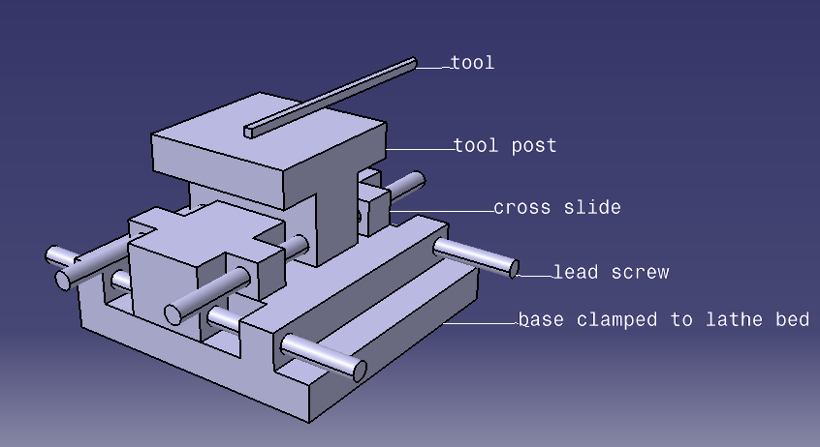

Fig 4.1 Catia model

After reception of array, the Arduino understands the shape of desired object based on it. The cutting algorithm fed to the Arduino controls the motion of the two stepper motors for the desired cut. According to the received array the cutting algorithm starts the cut. For any job, the controller will first perform a “rough cut” and then later it will go for a “finished cut”. The type of cut varies according to shape or inclination of the job. Hence, manufacturing of different jobs may involve different types of cuts. As the entire array is first analyzed by the controller, and then based on the type of cuts, their position and number, the controller decides which cut to be performed first. Hence, the cuts are performed in the most appropriate order.

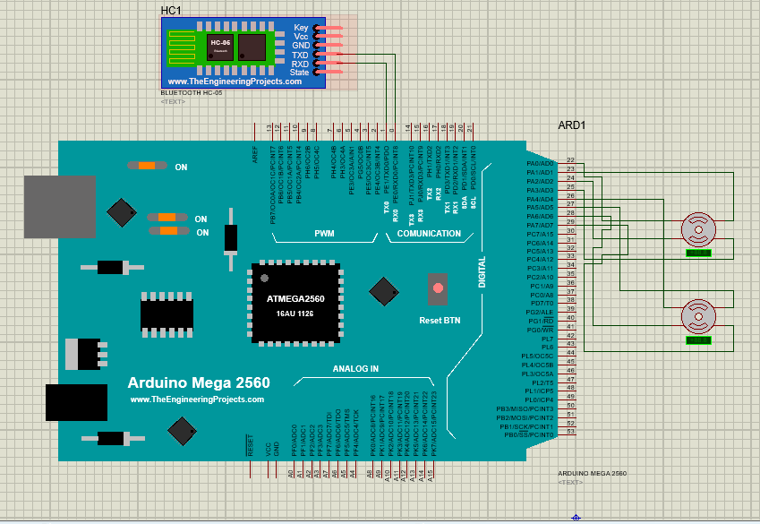

Fig 4.2 Arduino

Coding algorithm:

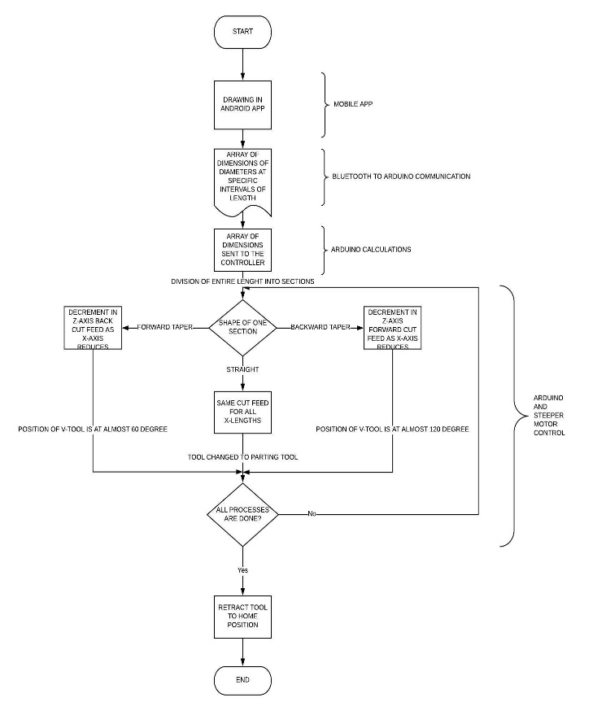

Fig 4.3 Flow Chart

V. FEEDBACK CONTROL

Stepper Motors provide very accurate angle of rotation as codded. This will in turn move the lead screws precisely to the required position. But if the motor goes haywire then the tool can move much deeper into the work piece. This will cause severe damage to the Extension and some fragile parts may break.

To avoid this feedback control becomes mandatory. Two IR distance sensors are used to keep a track on the two axes of motion. They work on the principle of transmitting and receiving IR light and measuring the time required to do so. The sensors are placed such that they can track the motion of the flat surface in front of them.

The error of the stepper motor can be observed by the IR sensors and if necessary be rectified by commanding the stepper motor accordingly.

VI. SAFETY PRECAUTIONS

There are two major forces acting on the tool tip namely Ft - Thrust Force and Fc - Cutting Force. If they exceed a certain critical limit, then tool edge may get blunt rapidly. The forces exceed the limit if the feed rate or the depth of cut is more than the specifications. For measurement of these perpendicular force two strain gauges are used.

While cutting operations friction is always present. Friction between the tool and the workpiece leads to high heat release. This may increase the temperature of the workpiece above the fusing point. It causes a small amount of molten metal to accumulate on the tool tip making it blunt. Thus, a check on rise in temperature is also necessary in cutting operations. For this a temperature sensor is attached and the temperature of the tool is checked continuously.

The main motor on the lathe which rotates the spindle is heavy duty, high torque motor. During its operation high amount of vibration is created. These vibrations travel through the gear box the whole machine. Vibration cause the surface of the machined workpiece to be uneven. The finish of the surface is also compromised. We can’t remove the vibration but surely can stop the operation if the amplitude becomes too large. Then if the problem is analyzed and solved the operation may resume. For this a vibrometer is mounted on a location where the maximum amplitude of vibration will be recorded. This location must be as far as possible from any supporting structure.

VI. ADVANTAGES

1.No skilled labor needed

2.Direct connection to the design engineer can be established

3.Basic drawing of the part in needed.

4.Manual lathe can be obtained by detaching the extension

5. Producing the same quality for all work parts as done by CNC lathe machines.

6. Better dimensional accuracy than manual lathe which gives exact and correct dimensions.

VII.CONCLUSION

Using this extension, we are reducing the work of the laborer as well as giving the design engineers a clear path to the machine itself. Here, the worker is only needed to load and unload the work piece, rest of the things like uploading the file into the controller can be done by the engineer in the office. This will not only that there is reduction in lot of paper work like hard copy of drawing files, etc. The extension will have lesser cost than the full functional CNC, hence introduction of this extension can prove a boom to small scale industries.  
Also, the wastage of metal or internal mechanism of old lathe can be avoided as we are using the same spindle provided in the old machine. Finally, the functionality of manual lathe will always sustain in this world of automation.

REFERENCES

[1] Review on Advance Automation of Conventional Lathe Machine

[2] In 2013, M. Moses & Dr. Denis Ashok M. Tech, Mechatronic from School of Mechanical and Building Science, VIT University, Vellore, India 978-1-4673-6150-7/13/$31.00 ©2013 IEEE

[2] We have also used following links,

http://en.wikipedia.org/wiki/Numerical_control

http://en.wikipedia.org/wiki/Lathe

# 